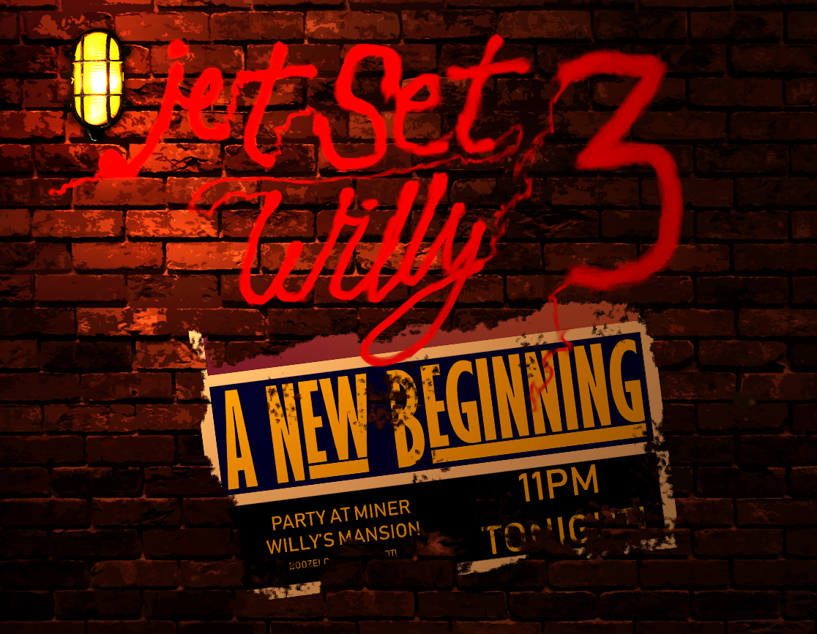

Design Document for:

Jet Set Willy 3: A New Beginning

All work Copyright ©2018 by Reboot Games

Written by Luke Bruni

Version # 1.00

Jet Set Willy 3: A New Beginning 1
Game Overview 3
Gameplay 4
The Game World 5
Overview 5
World Feature #1 5
World Feature #2 5
The Physical World 5
Overview 5
Key Locations 5
Travel 5
Scale 5
Objects 5
Weather 5
Day and Night 5
Time 6
Rendering System 6
Overview 6
2D/3D Rendering 6
Camera 6
Overview 6
Camera Detail #1 6
Camera Detail #2 6
Game Engine 6
Overview 6
Game Engine Detail #1 6
Water 6
Collision Detection 6
Lighting Models 7
Overview 7
Lighting Model Detail #1 7
Lighting Model Detail #2 7
The World Layout 8
Overview 8
World Layout Detail #1 8
World Layout Detail #2 8
Game Characters 9
User Interface 10
Overview 10
Musical Scores and Sound Effects 11
Overview 11
Red Book Audio 11
3D Sound 11
Sound Design 11
Multiplayer Game 12
Overview 12
Max Players 12
Servers 12
Customization 12
Internet 12
Gaming Sites 12
Persistence 12
Saving and Loading 12

Game Overview

Game Description

Willy is back after a long relaxing break, but it's not the comeback he was expecting. After a huge party, a hungover Willy gets a visit from a nemesis: The Taxman! After skimping on his taxes and cashing out on necessities for himself, it turns out that the taxman is gonna get his sick dream of repossessing ol' Willy. Now, our hero must scrounge his own bizarre, party ridden mansion to find his money or the taxman will take all of what he has earned!

‘Jet Set Willy 3: A New Beginning’ is the third unofficial sequel and homage to that of an icon to 80's British gaming. What I aim to create is a game that captures the original gameplay of the past games and build upon that a slight bit of combat and a small humorous story. The player must find any available money around the mansion, traverse many obstacles and avoid any enemies to help pay off the Taxman's debt.

Gameplay

Overview

The game begins with Willy waking up at around 7:00AM, hungover and smelling of expensive vodka. He gets a knock at the door and he goes to answer it to reveal the taxman with his goons. A devilish grin on his face as he says to him that his payments are overdue, shocking poor Willy with the thought of having everything taken from him. The door is slammed on his face leading willy to quickly gather his money from the mansion.

The gameplay will match the original nonlinear style of the game where the player can explore all his mansion at will and take different approaches to getting to the goal. To help with the exploration, the game is not divided into "rooms" (A.K.A the game's not flip-screen").

The game takes the same approach to collecting items, but rather than the item negating from a counter the amount of money found inside that item or the value of that item will add to the money counter. The money takes on many forms, like stated before, money can be picked up inside objects in the house or found in various places. Money is more the aim here and Willy must collect enough money to fulfil a quota. This quota will change and the game will change along with it, altering some of the levels. Quotas will keep being fulfilled to progress the game's story until the end.

The Game World

Overview

The game takes place within Willy’s Mansion and to reflect on his wealth, Willy’s mansion will be designed as a larger than life mansion, built on his wildest, drunken dreams

Game Characters

Player

The player takes control of the main character, Miner Willy. A semi-retired miner and playboy, owner of a large mansion filled with bizarre things and generally where he spends all his life in. To prevent his mansion from being repossessed, he must find enough money to pay off the taxman's huge debt.

Willy can now fight, throw punches and knock enemies out. Sure, blood may be spilled along the way, but the combat won't be a staple in the mechanics (there won't be any weapons as well), being that the game focuses in the platforming, where fighting will be as a last resort or saved as part of a certain mission.

His platforming ability has improved immensely; he can grab ledges, run, duck and roll, which should add some tense action to his adventures.

Enemies

The enemies in Jet Set Willy 3 are far random, dependant on the room that willy could go in or some that just come up from time to time. The main enemies that Willy will encounter alongside these enemies and static hazards:

- Repo Men
- Party Goers
- The Taxman himself!
- And many more!

User Interface

Overview

As the game is mainly derived from its prequels, the interface should be simple enough for the user and not be needlessly complicated at all. Menus are simple, being there will be some options to configure and something for the extra features; a basic main menu system with some extra aesthetics that match the design of the game.

Regarding the UI for the initial game, it will function similarly to that of the original games. i.e. the location names and objectives (items collected in the old games, money in this sequel). The HUD will be updated and designed to allow for the game to be centre stage and not take up a portion of the screen.

Primary Controls

Action | Key Binding
Move Left | 'A'/Left Key
Move Right | 'D'/Right Key
Jump | 'W'/SPACE/Up Key
Duck | CTRL/Down Key
Roll | SHIFT
Punch | Left Mouse
Block | Right Mouse
Interact | 'E'
Pause | ESC

Musical Scores and Sound Effects

Overview

This should probably be broken down into two sections but I think you get the point.

Red Book Audio

If you are using Red Book then describe what your plan is here. If not, what are you using?

3D Sound

Talk about what sort of sound APIs you are going to use or not use as the case may be.

Sound Design

Take a shot at what you are going to do for sound design at this early stage. Hey, good to let your reader know what you are thinking.

Multiplayer Game

Overview

Describe how the multiplayer game will work in a few sentences and then go into details below.

Max Players

Describe how many players can play at once or whatever.

Servers

Is your game client-server or peer-to-peer or whatever.

Customization

Describe how the players can customize the multiplayer experience.

Internet

Describe how your game will work over the internet.

Gaming Sites

Describe what gaming sites you want to support and what technology you intend to use to achieve this. Perhaps Dplay or TCP/IP or whatever. It is probably a good idea to break the tech stuff out into a separate area, you decide.

Persistence

Describe if your world is persistent or not.

Saving and Loading

Explain how you can save a multiplayer game and then reload it. If you can or why this is not possible.

